**Run Jenkins at Scale with Distributed Builds on Kubernetes**

Created Jenkins Namespace k create namespace jenkins –-dry-run=client -o yaml > ns.yaml

apiVersion: v1

kind: Namespace

metadata:

creationTimestamp: null

name: jenkins

spec: {}

status: {}

K apply -f ns.yaml

Create deploy with image - jenkins/jenkins:2.375.1-lts



Create a service jenkins as below

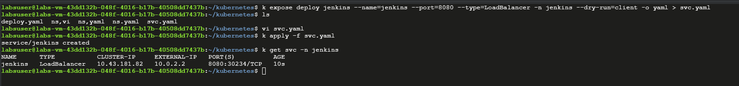

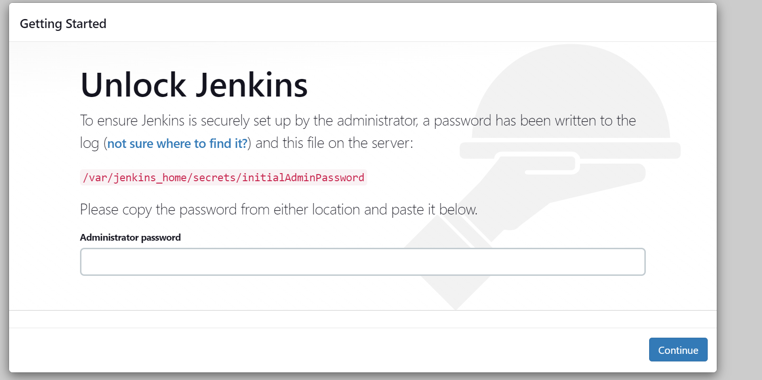

Get the password by logging into pod/var folder

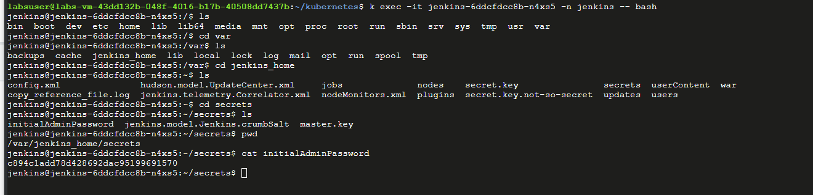

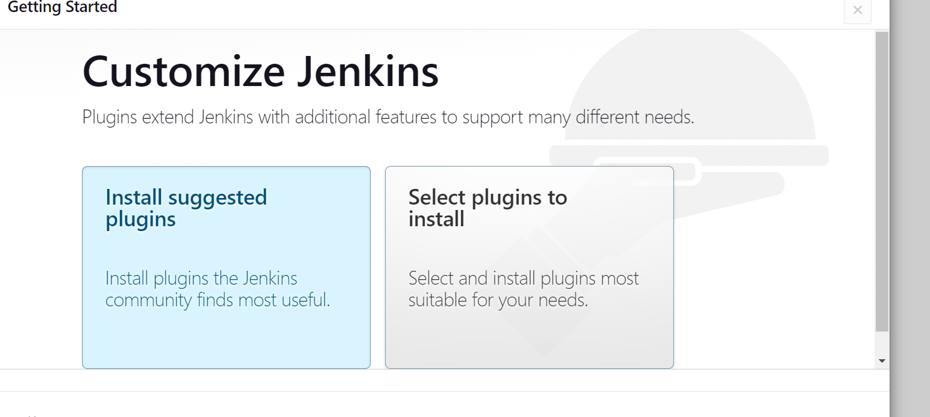

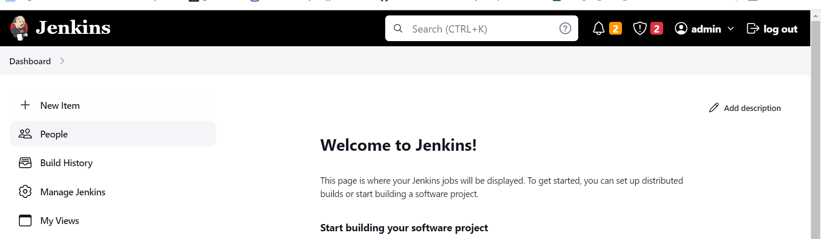

Delete and re-created the POD. Jenkins will dis-appear.

You will see that all the configurations that you applied are lost, and that's because the pod doesn't have any persistent storage.

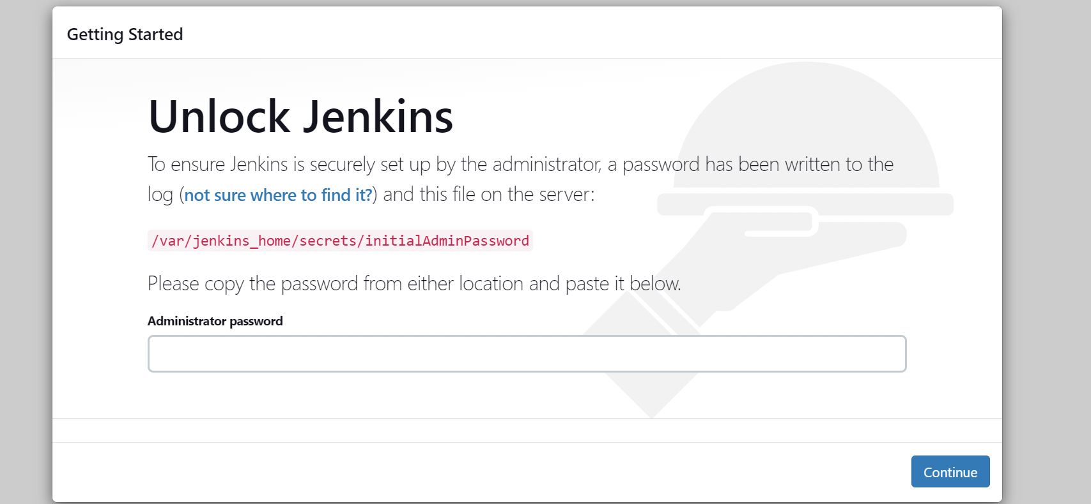

Crated PVC

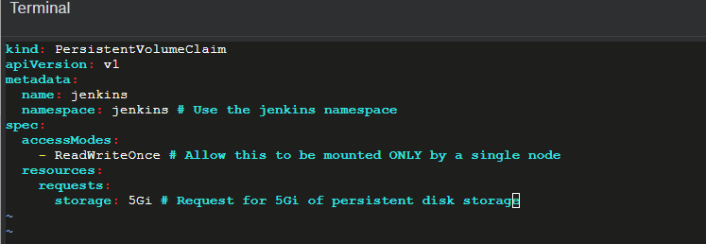

Created PVC, waiting for volume bound

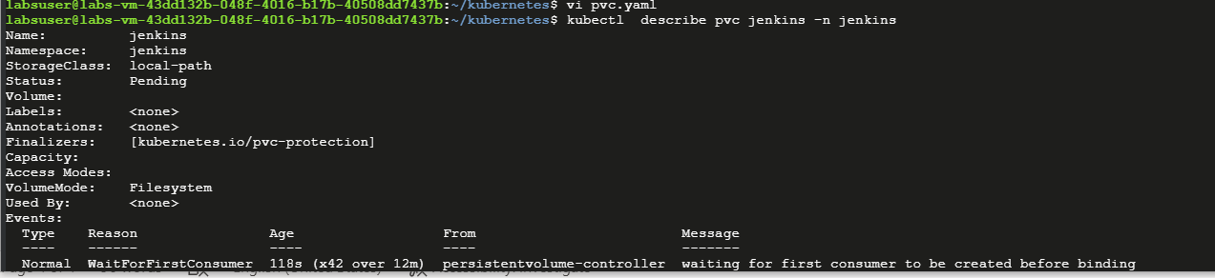

Apply to deploy:

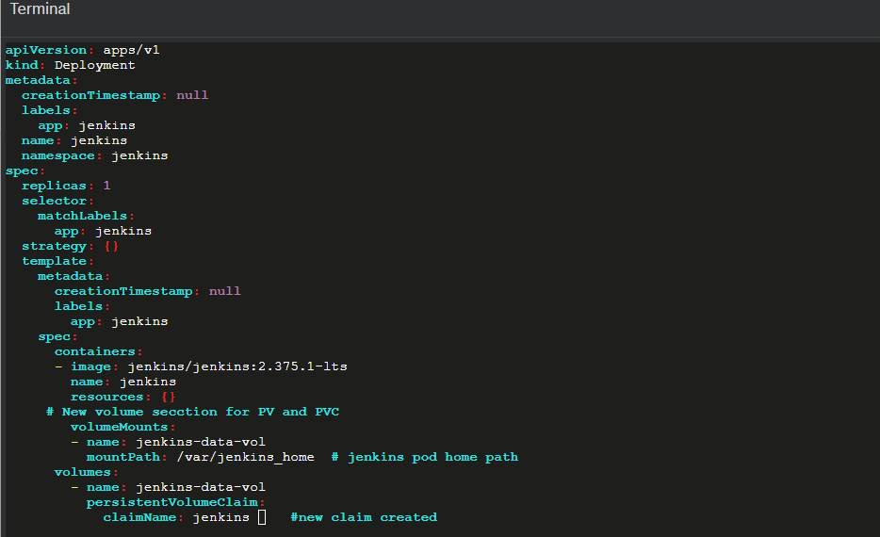

Persistent claim got attached to volumeclaim

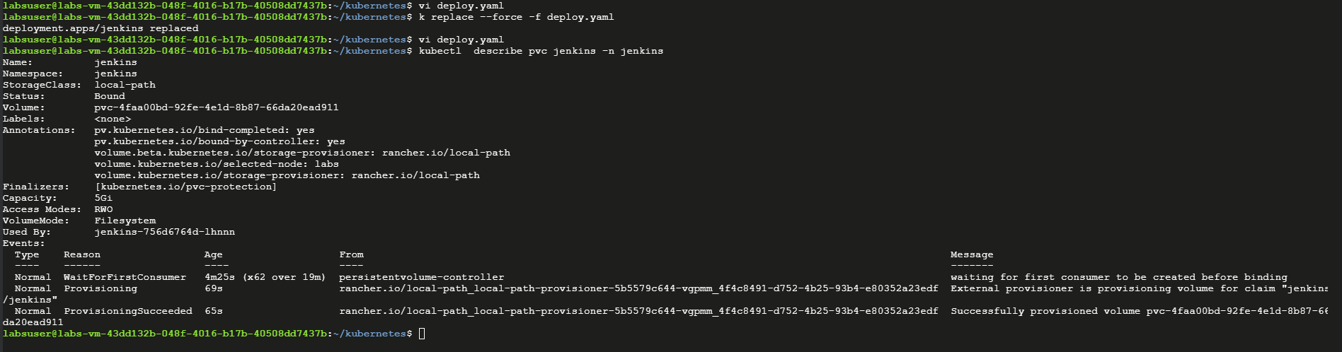

Get jenkins password

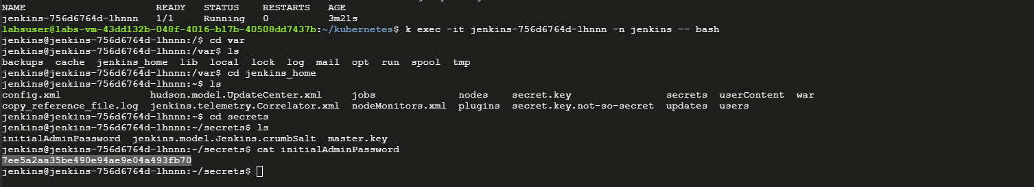

Jenkins got up by using the new password

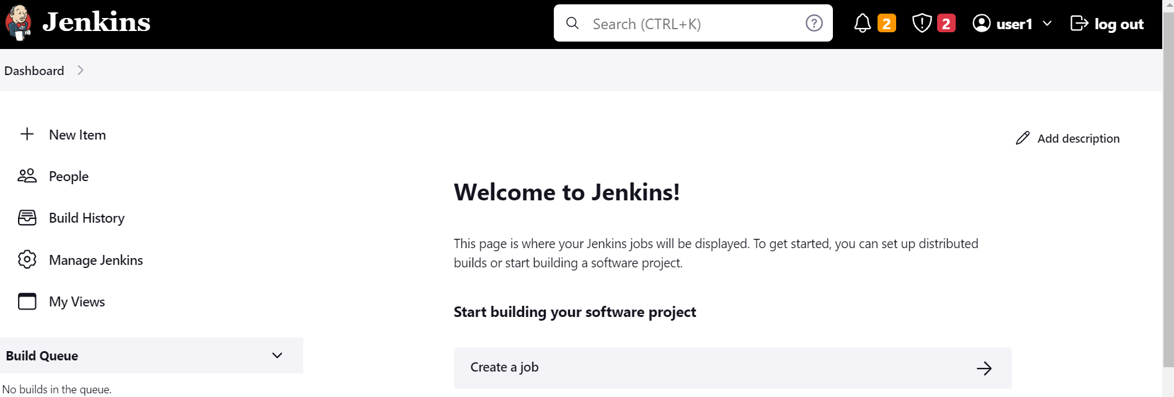

After I delete POD, jenkins just ask for password we create

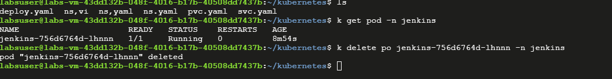

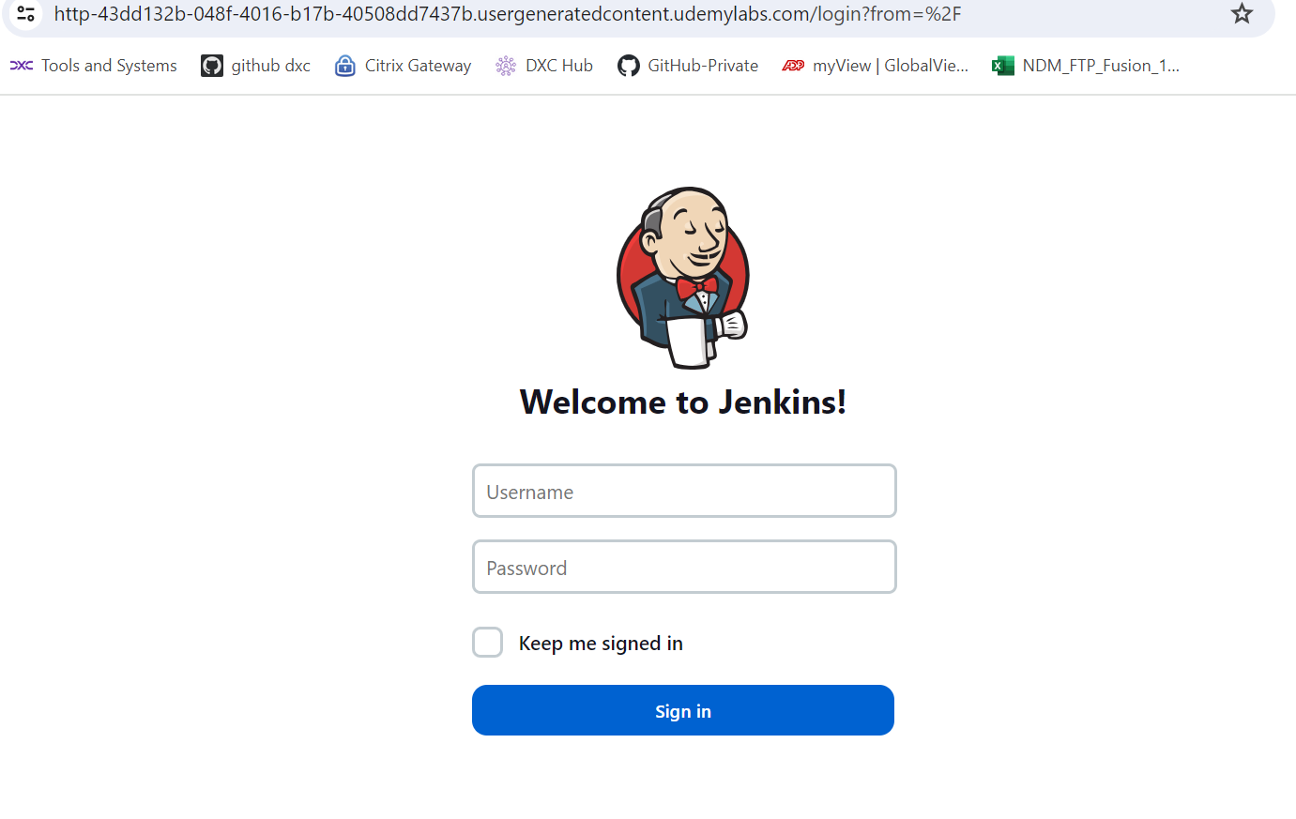

POD is up and jenkins can be logged in with old password.

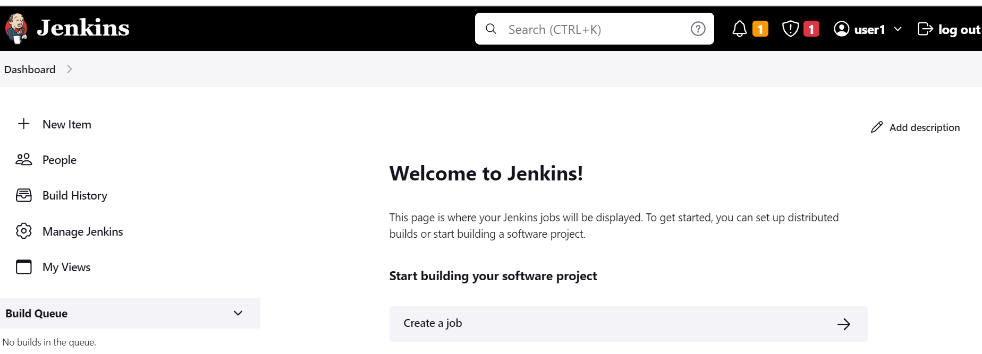

Configure the RBAC executor for jenkins executor

* Create SA account jenkins (k create sa jenkins -n jenkins)
* 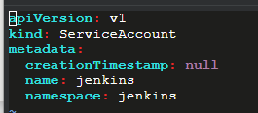
* Setup deploy to run only from jenkins sa account
* 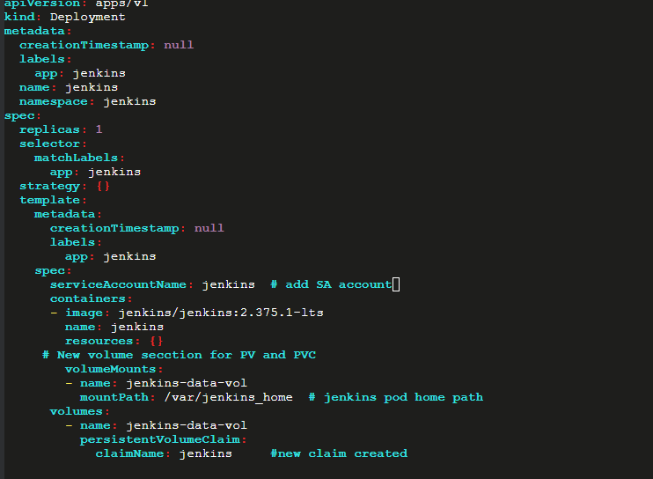
* Create RBAC - jenkins-executors – role and role binding

Role:

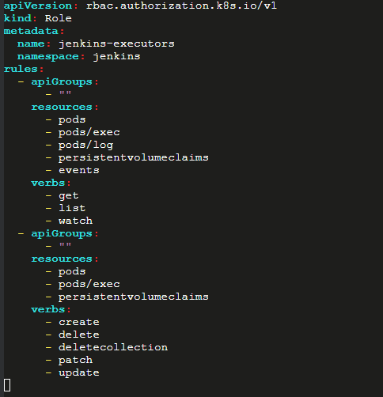

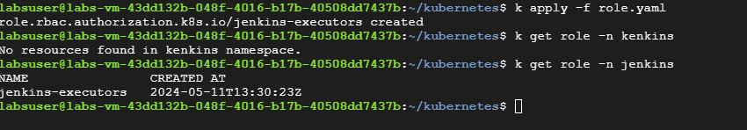

Role Binding:

k create rolebinding jenkins --role=jenkins-execcutors -n jenkins --serviceaccount=jenkins:jenkins --dry-run=client -o yaml > bind.yaml

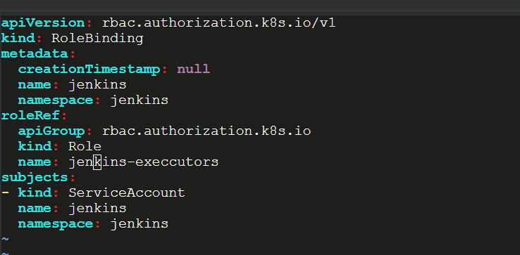

Noe recreate deployments

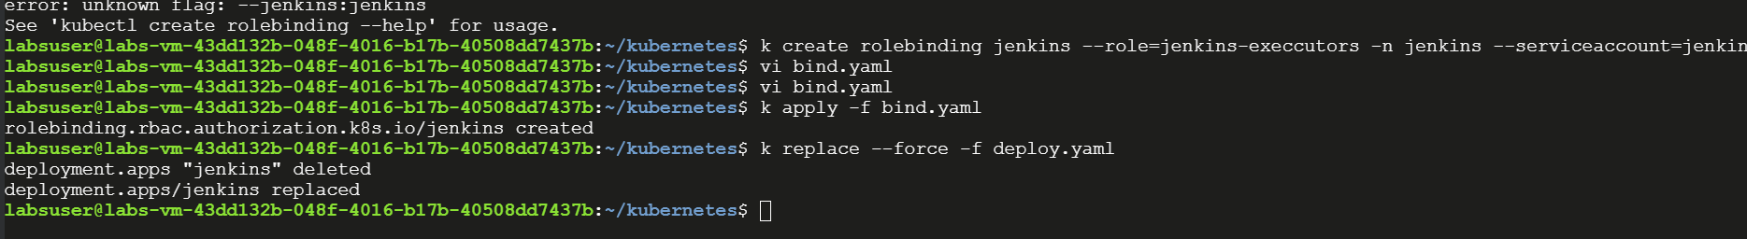

Added executor port

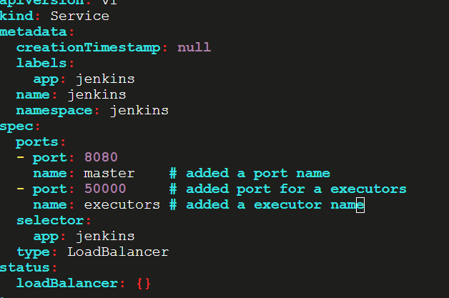

Recreated a svs:

